DESIGN AND IMPLEMENTATION OF A MOTION-ACTIVATED REAL-TIME INTERACTIVE LED DEPARTMENTAL SCHEDULE DISPLAY.

BY

ATAYI WISDOM
21/58437/ UE
&
DEMKAA A. JOSHUA
21/58439/ UE

DEPARTMENT OF ELECTRICAL AND ELECTRONICS ENGINEERING,
JOSEPH SARWUAN TARKA UNIVERSITY, MAKURDI.

June, 2026
DESIGN AND IMPLEMENTATION OF A MOTION-ACTIVATED REAL-TIME INTERACTIVE LED DEPARTMENTAL SCHEDULE DISPLAY.

BY

ATAYI WISDOM
21/58437/ UE
&
DEMKAA A. JOSHUA
21/58439/ UE

Project Submitted to the Department of Electrical and Electronics Engineering,
Joseph Sarwuan Tarka University, Makurdi in Partial Fulfilment of the Award of Bachelor
of Engineering in Electrical and Electronics Engineering.

June, 2026

DECLARATION
We declare that the work described in this project is original, and has not been previously submitted to any university or similar institutions for the award of any degree or certification.

Name of Candidates: ATAYI WISDOM
Registration Number: 21/58437/ UE

Signature: ………………………………………………………………………….
Date……………………………………………………………………………...

Name of Candidates: DEMKAA A. JOSHUA
Registration Number: 21/58439/ UE
Signature: ………………………………………………………………………….
Date……………………………………………………………………………...

CERTIFICATION
We, the undersigned, hereby certify that this research project presented by ATAYI WISDOM (21/58437/ UE) and DEMKAA A. JOSHUA (21/58439/ UE) is accepted as fulfilling part of the requirements for the award of the degree of Bachelor of Engineering in Electrical and Electronics Engineering.
Title: Design And Implementation Of A Motion-Activated Real-Time Interactive Led Departmental Schedule Display.

Engr. Iannah ………………………………….
Supervisor Signature/ Date

Engr. Madukwe C. A. …………………………………
Project Coordinator Signature/ Date

Engr. Dr E. T. Iorkayse …………………………………
Head of Department Signature/ Date

DEDICATION
This work is dedicated to our Lord God Almighty for His mercies each day and for sustaining us through this project work.

ACKNOWLEDGEMENT
We return all honour and glory to God Almighty, whose mighty hand has kept us through this process that was seemingly impossible at the start. His grace, wisdom, and awesome power made it possible for us. We literally saw his hand at every point in the work, which words alone cannot express our gratitude.
We express our heartfelt gratitude to our project supervisor, Engr. A.S. Iannah, for who he is, cannot be captured here in totality for want of words. His unwavering commitment, professional guidance, and constructive feedback throughout the research and implementation process. The most amazing part is his technical depth and logical thinking, which moulded this work and has brought it to this standard. The encouragement and timely interventions played a significant role in bringing this masterpiece to life.
Our sincere appreciation also goes to the Department of Electrical and Electronics Engineering, Joseph Sarwuan Tarka University, for providing a conducive academic environment and the necessary resources that supported this research.
We are deeply thankful to our lecturers and departmental staff for their dedication, mentorship, and contributions toward building our knowledge in intelligent systems and embedded technologies.
We also acknowledge our colleagues and friends whose suggestions, discussions, and assistance enriched the development of this work in many ways.
Above all, we extend our heartfelt appreciation to our families for their constant moral support, patience, and belief in us throughout this journey. Their encouragement remained a source of strength and motivation.

Table of Contents

DECLARATION ii
CERTIFICATION iii
DEDICATION iv
ACKNOWLEDGEMENT v
1 INTRODUCTION 1
1.1 Background of the Study 1
1.2 Statement of the Problem 2
1.3 Aim of the Study 3
1.4 Objectives of the Study 3
1.5 Significance of the Study 3
1.6 Scope of the Study 4
2 LITERATURE REVIEW 5
2.1 Theoretical Framework 5
2.1.1 Flexible 32 × 16 RGB LED Matrix Display 5
2.1.2 ESP32 Microcontroller 6
2.1.3 Passive Infrared (PIR) Motion Sensor – HC-SR501 7
2.1.4 DS3231 Real-Time Clock Module 8
2.1.5 4 × 4 Matrix Keypad 9
2.1.6 Bluetooth Communication Interface 10
2.1.7 Web-Based Interface via Wi-Fi Access Point Mode 10
2.1.8 Backup Rechargeable Power Supply 11
2.1.9 BC547 Transistor and 1N4007 Diode 11
2.2 Conceptual Framework 12
2.3 Review of Related Empirical Studies 13
2.4 Summary of Literature Review 15
3 CIRCUIT ANALYSIS AND DESIGN 17
3.1 Introduction 17
3.2 ESP32 Microcontroller – Central Control Unit 17
3.3 Flexible 32 × 16 RGB LED Matrix – Electrical Analysis 19
3.3.1 LED Current Consumption and Power Supply Sizing 19
3.3.2 Decoupling Capacitors for LED Modules 19
3.4 PIR Motion Sensor (HC-SR501) Interface 20
3.5 DS3231 Real-Time Clock Module Interface 21
3.5.1 I²C Pull-up Resistor Verification 21
3.6 4 × 4 Matrix Keypad Interface 22
3.7 Buzzer Driver Circuit – BC547 Transistor Switch 23
3.7.1 Base Resistor Calculation 23
3.7.2 Diode – 1N4007 23
3.8 Status LED Indicator Circuits 24
3.8.1 Series Resistor Calculation 24
3.9 Power Supply Circuit – Analysis and Design 25
3.9.1 Step-Down Transformer Selection 25
3.9.2 Full-Wave Bridge Rectifier 25
3.9.3 Filter Capacitor Calculation 26
3.9.4 Voltage Regulation – LM2596 Buck Converter 26
3.9.5 3.3 V Rail – AMS1117-3.3 Linear Regulator 27
3.9.6 Backup Battery Sizing 27
3.9.7 Filter Capacitor Sizing for the 5 V Rail at Each LED Module 27
3.10 Circuit Diagram 28
3.11 System Flowchart 29
3.12 Programming 31
3.12.1 Programming Language Choice 31
3.13 Summary of Circuit Design 32
REFERENCES 33

TABLE OF FIGURES
Figure 2.1 2.1.1 Flexible 32 × 16 RGB LED Matrix Display 13
Figure 2.2 ESP32 Microcontroller 14
Figure 2.3 Passive Infrared (PIR) Motion Sensor – HC-SR501 15
Figure 2.4 DS3231 Real-Time Clock Module 16
Figure 2.5 4 × 4 Matrix Keypad 16
Figure 3.1 Complete Circuit Diagram of the Motion-Activated LED Schedule Display System 33
Figure 3.2 System Operational Flowchart 35

TABLE OF TABLES

Table 3.1ESP32 GPIO Pin Allocation for the Schedule Display System 18
Table 3.2 PIR Sensor (HC-SR501) to ESP32 Connection 20
Table 3.3 DS3231 RTC Module to ESP32 Connection 21
Table 3.4 Keypad Pin Mapping to ESP32 GPIO 22
Table 3.5 Summary of Power Requirements for All System Components 28
Table 3.6 System State Truth Table 31

INTRODUCTION

Background of the Study
The effective dissemination of lecture schedules, course details, and venue information is essential for the smooth academic progress of students in any higher education institution. In university departments across Nigeria, including Benue State, the traditional method of displaying lecture timetables has remained largely unchanged for decades. This work highlights the persistent challenges of traditional paper-based timetable displays in Nigerian universities, which have poor visibility, deterioration, difficult updates, lack of organisation. Erratic mains electricity in regions like Makurdi further cripples digital displays during power outages.

Modern embedded systems, particularly the ESP32 microcontroller (high speed, Wi-Fi, Bluetooth, ample memory), enable affordable, automated LED notice boards, as demonstrated in prior research (Sarkar et al., 2023; Triwahyuni & Beta, 2022). PIR motion sensors can conserve energy by activating displays only when people are present (Mashrur, 2025), while the DS3231 RTC provides accurate, battery-backed timekeeping for schedule-aware displays without internet (BAA PAVANI et al., 2025). Flexible 32×16 LED panels can be cascaded to form a 64×16 matrix, showing course codes, times, and venues, and a 4×4 keypad allows students to filter schedules by academic level. Crucially, a rechargeable backup power system (battery, charger, automatic changeover) ensures uninterrupted operation during mains failures. Although previous works have produced digital notice boards, few integrate all these features multi-modal updates (Bluetooth and web admin), motion activation, RTC, level-based filtering, flexible large-matrix display, and backup power. The present project aims to fill this gap by designing and implementing such a system tailored for the Nigerian university context.

The persistence of paper-based timetable displays in Nigerian university departments creates a number of practical difficulties that directly affect students and staff. Printed timetables are easily torn, faded by sunlight, or damaged by humidity, and once posted they are rarely updated promptly when lecture venues or times change, leaving students to rely on outdated information. A single notice board also cannot present a large, clearly visible timetable for an entire department from across a busy corridor, so students must crowd around the board to read small print. Where departments have attempted electronic alternatives such as plasma screens or computer monitors, these solutions are frequently rendered useless by the frequent and unpredictable mains power interruptions that are characteristic of Makurdi and similar regions, since such displays have no backup power and lose all information the moment electricity is lost. In addition, existing electronic notice board projects in the literature tend to address only one or two of these issues at a time: some focus on remote updating without addressing energy efficiency, others address display size without addressing power continuity, and very few provide a simple, level-based filtering mechanism that allows individual students to quickly locate only the classes relevant to them rather than scanning an entire departmental timetable.

This project addresses these problems by designing and implementing a single integrated system that combines a large, highly visible 64 × 16 flexible LED matrix display with motion-based activation, real-time clock scheduling, dual wireless update methods, level-based keypad filtering, and a rechargeable battery backup with automatic changeover. The work begins with a review of the individual technologies required the ESP32 microcontroller, the WS2812B LED matrix, the PIR motion sensor, the DS3231 real-time clock, the keypad interface, the wireless update interfaces, and the power supply and backup circuitry before proceeding to the detailed circuit analysis and design of each subsystem and its interconnection to the ESP32.

The final stage of the project, presented in subsequent chapters, covers the physical construction of the prototype, the development and testing of the firmware, and the evaluation of the completed system against the stated objectives, culminating in a fully functional, low-cost, motion-activated departmental schedule display suitable for deployment in a Nigerian university environment.

Statement of the Problem
The Department of Electrical and Electronics Engineering, like most departments at Joseph Sarwuan Tarka University, Makurdi, currently relies on printed paper timetables pinned to a departmental notice board to communicate lecture schedules, venues, and course codes to students across five academic levels. This method suffers from several well-known shortcomings: the printed sheets deteriorate quickly under humidity and frequent handling, are difficult and time-consuming for departmental staff to update whenever a change occurs, lack any form of automatic time-awareness, and provide no mechanism by which an individual student can quickly view only the classes relevant to their own level without reading through the entire timetable. Furthermore, electronic alternatives that could overcome these limitations are rarely adopted because they have no provision for the erratic mains power supply typical of the region, meaning that any digital display installed would simply go blank during the frequent outages experienced in Makurdi. There is therefore a need for a departmental schedule display that is large and clearly visible, automatically shows the correct lecture information for the current time and day without manual intervention, allows students to filter information by their academic level, can be updated remotely without removing or reprinting any physical material, conserves energy by activating only when someone is present to view it, and continues to operate normally during mains power interruptions through a rechargeable battery backup.

Aim of the Study
The aim of this study is to design a motion-activated, real-time interactive LED departmental schedule display.

Objectives of the Study
The specific objectives of this study are:
- To design a motion-activated LED departmental schedule display system using an ESP32 microcontroller and 64 × 16 WS2812B LED matrix, incorporating PIR-based human presence detection and DS3231 real-time clock for accurate, automated timetable display.
- To develop an interactive user interface that allows students to filter lecture schedules by academic level using a keypad and enables administrators to update timetable information remotely via Bluetooth and Wi-Fi Access Point web interface.
- To ensure reliable and continuous system operation through persistent data storage in ESP32 flash memory and the integration of a rechargeable battery backup system with automatic power changeover for use during mains failure.

Significance of the Study
The project demonstrates a low-cost, motion-activated schedule display using an ESP32 and a flexible LED matrix, offering practical benefits for Nigerian universities with unreliable power supply. It addresses seven key objectives: motion activation, real-time scheduling, a clear 64×16 LED display, level-based keypad filtering, dual update methods (Bluetooth and web), backup rechargeable power, and persistent data storage. The flexible matrix fits curved walls, and motion activation saves energy (as shown by Mashrur, 2025). Dual updates work without internet (Triwahyuni & Beta, 2022), and backup power ensures operation during outages.

Scope of the Study
The project designs and implements a motion-activated LED departmental schedule display. It uses an ESP32 microcontroller to control a 64×16 flexible LED matrix (cascaded from two 32×16 or four 32×8 WS2812B modules via FastLED). A PIR sensor (HC-SR501, GPIO4) detects human presence to activate the display, saving power. A DS3231 RTC with battery backup provides accurate timekeeping over I²C. Students select their academic level (100L–500L) using a 4×4 keypad (rows GPIO27,14,12,13; columns GPIO33-36). Schedule updates are possible through Bluetooth (ESP32 Classic), a web interface in Access Point mode (SSID “DeptSchedule_AP”, IP 192.168.4.1), or Wi-Fi network mode for OTA configuration uploads. Schedule data (course code, start/end time, venue, day, level) is stored persistently in flash via the Preferences library. The system is powered by a regulated 5 V/10 A supply with a backup rechargeable 12 V battery, charging circuit, and LM2596/AMS1117 regulators. Status LEDs (green standby, red active) and a buzzer provide feedback. It stores a full weekly timetable for all five levels of one department, displays 8-10 characters per row (scrolling for longer text), and is intended for indoor use in corridors or notice board

LITERATURE REVIEW

Theoretical Framework
The design of the motion-activated LED departmental schedule display rests on the convergence of three broad technological domains: embedded microcontroller systems, wireless communication protocols, and power electronics for battery-backed operation. According to Sarkar et al. (2023), the ESP32 system-on-chip has emerged as the preferred platform for networked embedded applications that require concurrent real-time and communication tasks, owing to its dual-core architecture and integrated wireless capabilities. Alongside this, the literature consistently demonstrates that passive infrared sensing, real-time clock modules, and addressable LED arrays constitute the essential building blocks for energy-efficient public information displays (Mashrur, 2025; Ifeagwu, 2025). The following sub-sections review each of these foundational components with respect to their operating principles, technical parameters, and relevance to the present project.

Flexible 32 × 16 RGB LED Matrix Display
The flexible 32 × 16 LED matrix module is a bendable panel populated with WS2812B individually addressable RGB LEDs arranged in 32 columns and 16 rows, yielding 512 LEDs per module. In this project, two such modules are cascaded to form a 64 × 16 display comprising 1,024 LEDs. Each WS2812B device integrates a control circuit and an RGB LED within a single package; it receives 24-bit colour data (8 bits per channel in the order Green–Red–Blue), extracts its own data, and forwards the remainder down the chain (Triwahyuni & Beta, 2022). This daisy-chain architecture necessitates only a single data wire from the microcontroller, substantially simplifying wiring compared with multiplexed matrix approaches that require dedicated row and column driver integrated circuits such as the MAX7219.
Control is effected through a single-wire Non-Return-to-Zero (NRZ) protocol operating at 800 kbps, in which a logical 1 is encoded as a high pulse of 0.8 µs followed by a low pulse of 0.45 µs, and a logical 0 as a high pulse of 0.4 µs followed by a low pulse of 0.85 µs. The ESP32 RMT (Remote Control) peripheral generates the precise timing required for this protocol (Sarkar et al., 2023). The FastLED library provides the software layer for setting individual LED colours, constructing scrolling text from a 5 × 7 pixel font bitmap, and managing the frame buffer. The flexible substrate of the module permits mounting on curved surfaces such as corridor pillars, while the diffused neon-style lens yields high visibility under ambient lighting conditions common in academic corridors.
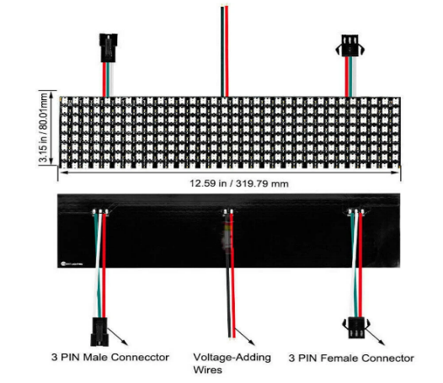
Figure 2.1 2.1.1 Flexible 32 × 16 RGB LED Matrix Display

ESP32 Microcontroller
The ESP32 is a low-cost system-on-chip developed by Espressif Systems, based on a dual-core Xtensa LX6 32-bit processor operating at up to 240 MHz. It serves as the central processing and control unit of the schedule display system. According to Sarkar et al. (2023), the ESP32 has been selected for systems of this class for its suitable processing performance, design flexibility, and cost-effectiveness. The module integrates a dual-mode Wi-Fi (802.11 b/g/n) and Bluetooth (Classic and BLE) radio with an onboard power amplifier, low-noise receive amplifier, and power management unit (Triwahyuni & Beta, 2022).
The dual-core architecture is particularly advantageous for this project: one core can continuously monitor the PIR sensor output and manage the power state of the LED display, while the second core concurrently handles I²C communication with the real-time clock, schedule retrieval from flash memory, and management of the web server and Bluetooth communication interfaces (Espressif Systems, 2023). The device operates at 3.3 V logic and is powered through its VIN pin at 5 V, with an onboard AMS1117-3.3 low-dropout linear regulator supplying the 3.3 V rail to internal circuitry and peripherals.

Table 2.1: ESP32 Microcontroller Specifications
Parameter | Value
Operating Voltage | 3.3 V DC
Input Voltage (VIN) | 5–12 V DC
Processor | Dual-core Xtensa LX6 @ 240 MHz
SRAM | 520 KB
Flash Memory | 4–16 MB (module dependent)
Wi-Fi | 802.11 b/g/n (up to 150 Mbps)
Bluetooth | v4.2 BR/EDR and BLE
Active Current (Wi-Fi on) | ~250 mA (max)
Deep-sleep Current | 0.15 mA (150 µA)
GPIO Pins | 34 (programmable)

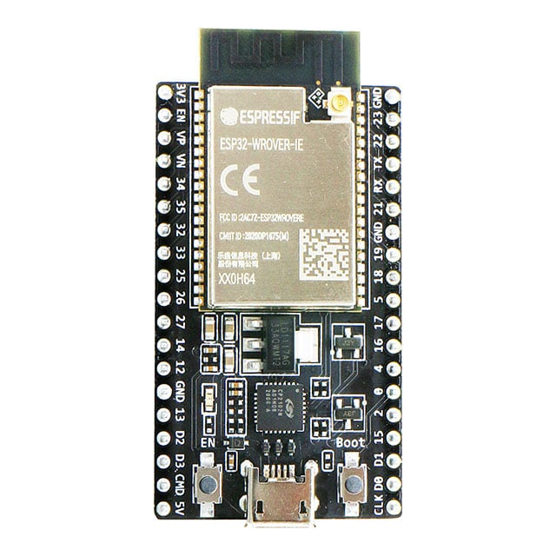
Figure 2.2 ESP32 Microcontroller

Passive Infrared (PIR) Motion Sensor – HC-SR501
A passive infrared (PIR) motion sensor detects human presence by measuring changes in infrared radiation emitted by warm bodies within its field of view. The HC-SR501 module comprises a pyroelectric sensing element, a Fresnel lens that concentrates infrared energy onto the element, and onboard signal-conditioning circuitry that converts a detection event into a logic-level digital output readable by a microcontroller (Mashrur, 2025). The operating principle is that all bodies above absolute zero emit infrared radiation, and the sensor responds specifically to the rapid spatial changes in the infrared field caused by a moving warm body traversing its detection zone (Futagami, 2024, as cited in Mashrur, 2025).
The HC-SR501 includes two adjustable potentiometers: one governs detection sensitivity (effective range 3–7 m) and the other governs the duration the output remains HIGH after the final motion detection (approximately 5 s to 5 min). The digital output is active-HIGH, producing 3.3 V logic compatible with the ESP32. The module requires a warm-up period of approximately 30–60 s after power-on, during which spurious output transitions may occur; the firmware therefore ignores the PIR output during initialisation. In this project, the sensor triggers the activation of the LED matrix display through an interrupt on the ESP32, enabling energy-efficient operation by keeping the display off during unoccupied periods (Mashrur, 2025).
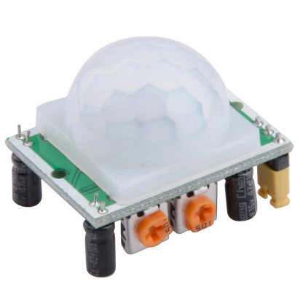
Figure 2.3 Passive Infrared (PIR) Motion Sensor – HC-SR501

DS3231 Real-Time Clock Module
The DS3231 is a highly accurate, temperature-compensated crystal oscillator (TCXO) real-time clock designed for applications requiring long-term timekeeping precision. It integrates a 32.768 kHz crystal resonator and provides a timekeeping accuracy of ±2 parts per million (ppm) across a temperature range of 0 °C to 40 °C, which translates to an annual drift of approximately ±1 minute (Espressif Systems, 2023). The device maintains seconds, minutes, hours, day-of-week, date, month, and year, with automatic adjustment for months having fewer than 31 days and leap-year compensation up to 2099.
Communication with the ESP32 is via the I²C serial bus, with the DS3231 operating as a slave at address 0x68. The module includes onboard 4.7 kΩ pull-up resistors on the SDA and SCL lines and a CR2032 lithium coin cell holder for battery-backed timekeeping during mains power interruptions. The use of a hardware RTC eliminates the time drift inherent in software-based timing loops and ensures that the schedule display remains synchronised with actual time even after power cycling, which is essential for a reliable, schedule-driven system in a Nigerian university environment where power interruptions are frequent.

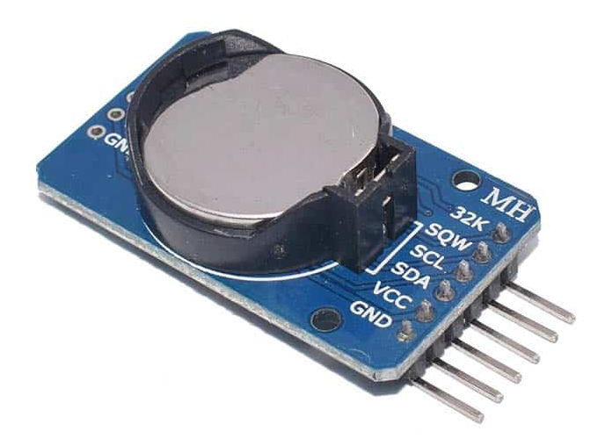
Figure 2.4 DS3231 Real-Time Clock Module

4 × 4 Matrix Keypad
The 4 × 4 matrix keypad consists of sixteen momentary push-button switches arranged in four rows and four columns, with keys labelled 0–9 and A–D. The ESP32 scans the keypad by sequentially asserting each row pin LOW and reading the four column pins, which are held HIGH by internal pull-up resistors. When a key is pressed, it creates a low-impedance path between the active row and the corresponding column, causing that column pin to read LOW and uniquely identifying the pressed key (Ifeagwu, 2025). A 50 ms software debounce delay is implemented to suppress contact bounce and ensure that each physical key press registers as a single logical event.
In this project, the keypad serves a dual purpose: it allows students to filter the displayed schedule by their academic level (100L through 500L) by pressing keys 1–5, and provides administrators with a fallback input mechanism for schedule data entry should both wireless update interfaces be unavailable.

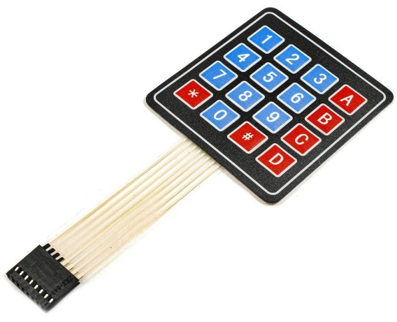
Figure 2.5 4 × 4 Matrix Keypad

Bluetooth Communication Interface
The ESP32 incorporates both Bluetooth Classic and Bluetooth Low Energy (BLE) radios, enabling direct wireless communication with mobile devices without requiring external radio modules (Triwahyuni & Beta, 2022). In this project, Bluetooth Classic is employed for schedule updates from a mobile application developed using MIT App Inventor. The ESP32 runs the BluetoothSerial library, which abstracts the Bluetooth protocol stack and presents a familiar UART-style serial interface to the application layer. When the mobile application transmits a formatted command string, the ESP32 parses the string, validates the parameters, updates the schedule record stored in the ESP32 flash memory via the Preferences library, and returns a confirmation response.

Web-Based Interface via Wi-Fi Access Point Mode
In addition to Bluetooth, the ESP32 provides a web-based schedule management interface by operating in Wi-Fi Access Point (AP) mode. In this configuration, the ESP32 creates its own local wireless network, allowing any Wi-Fi-enabled device smartphone, tablet, or laptop to connect without requiring an external internet connection (Triwahyuni & Beta, 2022). The AsyncWebServer library hosts an HTML form at the IP address 192.168.4.1. When an administrator submits the form, the browser issues an HTTP GET or POST request to the ESP32, which parses the parameters, updates the Preferences storage, and returns a confirmation page. This approach is well-suited to Nigerian university environments where institutional internet connectivity is often unreliable, as schedule updates can be made entirely over the local, self-contained network created by the device itself. As noted by Ifeagwu (2025), leveraging a Wi-Fi-enabled microcontroller for local web delivery eliminates the need for a separate cloud server while still providing an intuitive graphical interface for administrators.

Backup Rechargeable Power Supply
A backup rechargeable power supply is essential for ensuring continuous operation of the schedule display during mains power interruptions, which are endemic to Nigerian educational institutions. The backup system comprises a rechargeable battery (12 V lead-acid or lithium-ion), a constant-voltage constant-current (CV/CC) charging circuit, and voltage regulation stages for the 5 V and 3.3 V rails. The power supply unit converts incoming power from either the mains or the backup battery into the stable voltage and current levels required by the system components (Ifeagwu, 2025). An automatic changeover circuit, implemented with a relay or a dual-MOSFET ideal-diode arrangement, achieves seamless transition between mains and battery with a transfer time of less than 10 ms, which is short enough that the ESP32 does not reset.

BC547 Transistor and 1N4007 Diode
The BC547 is an NPN bipolar junction transistor (BJT) with a maximum collector current of 100 mA and a collector-emitter breakdown voltage of 45 V. In this system, it operates in saturation as a switch to drive the active buzzer, whose 30 mA operating current marginally exceeds the safe continuous output of an ESP32 GPIO pin. With a 1 kΩ base resistor and a 3.3 V drive signal, the base current is sufficient to saturate the transistor and deliver the required collector current to the buzzer load (Ifeagwu, 2025). The 1N4007 silicon rectifier diode, rated at 1 A forward current and 1000 V peak inverse voltage, is connected in reverse-bias across the buzzer terminals as a freewheeling diode to suppress the inductive voltage transient generated when the buzzer is de-energised, thereby protecting the transistor from reverse-voltage stress.
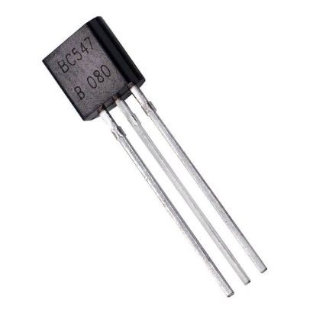  Figure 2.1.9 BC547 Transistor | 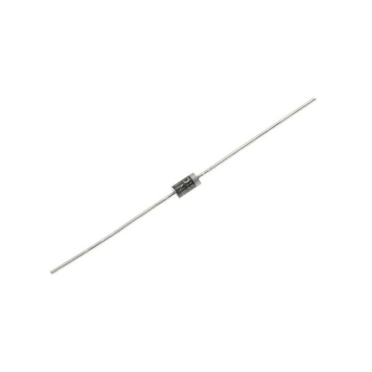  Figure 2.1.9 1N4007 Diode

Conceptual Framework
The conceptual framework for the motion-activated LED departmental schedule display is organised around an Input–Process–Output (IPO) model in which eight subsystems interact under the coordination of a central state machine resident on the ESP32 microcontroller. Inputs to the system include human presence signals from the PIR sensor, time-of-day data from the DS3231 RTC, academic-level selection from the keypad, and schedule data transmitted via Bluetooth or the Wi-Fi web interface. The ESP32 processes these inputs by retrieving the corresponding schedule records from non-volatile flash storage, applying any level filter requested by the user, and rendering the result as scrolling text on the 64 × 16 LED matrix. The output is a real-time, colour-coded display of current lectures including course code, time, and venue presented in an energy-efficient manner by activating the display only when human presence is detected.
The power subsystem underpins the entire framework by providing stable 5 V and 3.3 V supply rails to all components, with automatic transfer to a backup battery during mains failure. The data storage subsystem ensures that the complete weekly timetable for all five academic levels persists across power cycles using the ESP32 Preferences library. The remote update subsystems Bluetooth, Wi-Fi AP, and optionally a cloud-based platform allow administrators to modify the schedule without physical access to the device. The state machine coordinates transitions between four operational states INIT, STANDBY, ACTIVE, and UPDATE ensuring that the system enters low-power sleep when the corridor is unoccupied and resumes display within milliseconds of detecting renewed human presence. This framework satisfies all seven project objectives and is specifically designed for low-cost, reliable deployment in a Nigerian university department.

Review of Related Empirical Studies
Hercog et al. (2023) investigated the design and implementation of ESP32-based IoT devices for embedded and smart system applications. Their study demonstrated that the ESP32 microcontroller provides a highly efficient platform for real-time embedded systems due to its dual-core processor architecture, integrated Wi-Fi and Bluetooth modules, and low power consumption characteristics. The researchers emphasized that the ESP32 is capable of handling concurrent tasks such as sensor integration, wireless communication, and display control without performance degradation. This makes it suitable for interactive embedded systems requiring continuous data processing, such as real-time LED display boards. Their findings support the adoption of the ESP32 as the central processing unit in this project.
Ogunseye et al. (2021) designed and implemented a microcontroller-based electronic moving message display system using an LED matrix. Their work focused on replacing manual notice boards with automated electronic displays capable of scrolling messages in real time. The system demonstrated that LED matrix displays controlled by microcontrollers can effectively improve communication speed and visibility in institutional environments. However, the system was limited by the absence of wireless connectivity, meaning that content updates required physical interfacing with the controller. It also lacked automation features such as scheduling or motion-based activation. These limitations highlight the need for more advanced systems, such as the one proposed in this study.
Zaghlool Mahmood (2022) developed an ESP32-based automated school bell system integrated with a DS3231 real-time clock module. The system was designed to automate school schedules by triggering events based on precise time intervals. Experimental results showed that the DS3231 RTC module provides high accuracy and stability due to its temperature-compensated crystal oscillator. The study also demonstrated that ESP32-based systems can be configured via wireless communication, improving flexibility in institutional automation systems. However, the system did not incorporate display technologies or motion-triggered activation, which are central features of the current project.
Sarkar et al. (2023) developed an IoT-based performance display system using ESP32 and display modules for real-time information visualization. Their study confirmed that ESP32 is capable of managing both display rendering and wireless communication simultaneously, making it suitable for real-time monitoring applications. The system was able to update display content remotely and maintain stable performance under continuous operation. However, it was primarily focused on data visualization and did not integrate motion sensors or energy-saving activation mechanisms, which are essential in optimizing power usage in embedded display systems.
Ranasinghe and Herath (2023) proposed an IoT-based student flow monitoring system using ESP32 combined with PIR motion sensors and ultrasonic sensors. Their findings demonstrated that PIR sensors are effective for detecting human presence in indoor environments, with reliable response times and minimal false triggering when properly calibrated. The system was used to monitor classroom occupancy and automate attendance-related processes. This study is relevant to the present work because it validates the effectiveness of motion-based detection for triggering system responses, particularly in environments with intermittent human presence.
Sulartopo et al. (2023) developed a security monitoring system using ESP32 and PIR motion sensors for indoor environments. The system was designed to detect unauthorized movement and trigger alerts in real time. The results showed that PIR sensors provide low-cost and efficient motion detection capabilities suitable for embedded systems. The authors concluded that such sensors can be effectively used for automation and energy-saving applications. This directly supports the motion-activation feature proposed in the current project.
Barral Vales et al. (2024) examined time synchronization and fine time measurement techniques using ESP32 in IoT applications. Their study demonstrated that ESP32-based systems can maintain stable time synchronization even under variable network conditions. This is particularly important for real-time systems that depend on accurate scheduling and time-based event execution. Their findings support the reliability of ESP32 in time-sensitive applications such as departmental scheduling displays.
Krebs and Herter (2024) explored advanced ESP32-based positioning systems using ultra-wideband (UWB) modules for real-time tracking applications. Their research highlighted the flexibility of ESP32 in handling multiple external sensors and processing real-time data streams. The system achieved high accuracy in positioning and demonstrated strong performance in embedded environments. Although focused on positioning, the study reinforces the ESP32’s capability to support multi-functional embedded systems like the one proposed in this project.
Margapuri (2020) implemented a PIR-based smart motion detection system for automated response applications. The system demonstrated that PIR sensors are reliable for detecting human presence and can be integrated into embedded systems for automatic activation of devices. The study concluded that motion-based systems significantly improve energy efficiency by ensuring that devices operate only when required. This supports the energy-saving design principle used in the present project.
Ogunseye et al. (2021) further emphasized that LED matrix-based message display systems are effective for institutional communication due to their high visibility and flexibility. However, they noted limitations in scalability and the lack of remote configuration in traditional systems. These limitations justify the transition to wireless and automated LED display systems, which are addressed in modern ESP32-based implementations.

Summary of Literature Review
The reviewed empirical studies collectively demonstrate significant advancements in embedded systems, IoT communication, and real-time display technologies. Research by Hercog et al. (2023) and Sarkar et al. (2023) confirms that the ESP32 microcontroller is a robust platform capable of handling wireless communication, sensor integration, and display control simultaneously. This makes it suitable for real-time interactive LED display systems used in institutional environments.
Studies on LED matrix display systems, such as Ogunseye et al. (2021), establish that microcontroller-based displays can effectively replace traditional notice boards by improving visibility and communication speed. However, these systems often lack wireless update capabilities and automation features, limiting their efficiency in dynamic environments.
Motion detection studies by Ranasinghe and Herath (2023), Sulartopo et al. (2023), and Margapuri (2020) demonstrate that PIR sensors provide reliable and low-cost solutions for detecting human presence. These findings support the integration of motion-activated control mechanisms to reduce unnecessary energy consumption in display systems.
Furthermore, Zaghlool Mahmood (2022) and Barral Vales et al. (2024) highlight the importance of accurate time synchronization in automated systems, confirming that DS3231 RTC and ESP32-based time management systems are suitable for scheduling applications.
Despite these developments, existing systems generally implement isolated functionalities such as display control, motion detection, or scheduling independently. There is a clear gap in integrating motion activation, real-time scheduling, wireless update capabilities, and LED matrix display systems into a single unified platform. The present study addresses this gap by designing and implementing a motion-activated real-time interactive LED departmental schedule display system.

CIRCUIT ANALYSIS AND DESIGN

Introduction
This chapter presents the detailed electrical analysis and design of each subsystem constituting the motion-activated LED departmental schedule display. The discussion addresses the specific values of every passive and active component used in the design, the rationale for those values, and the calculations that confirm their suitability. The objective is to answer two questions that are fundamental to any engineering design: how were the component values determined, and why were those particular components chosen over alternatives? The system comprises the ESP32 microcontroller as the central control unit, two cascaded 32 × 16 WS2812B flexible LED matrix modules, an HC-SR501 PIR motion sensor, a DS3231 real-time clock module, a 4 × 4 matrix keypad, an active buzzer driven by a BC547 transistor, three GPIO-driven LED status indicators, and a regulated power supply with 12 V battery backup and automatic changeover. Each of these subsystems is analysed in turn.

ESP32 Microcontroller – Central Control Unit
The ESP32 microcontroller was selected as the system's central processing unit on account of four characteristics that distinguish it from available alternatives: its dual-core 240 MHz processing capability, integrated Wi-Fi and Bluetooth radio, hardware RMT peripheral for precision one-wire LED timing, and a deep-sleep current of 0.15 mA that enables energy-efficient standby operation. A single-core microcontroller such as the Arduino Mega 2560 was considered but rejected because it lacks Wi-Fi connectivity, requires an external Bluetooth module, and does not include the RMT peripheral necessary for generating the 800 kbps WS2812B timing with the accuracy required by the LED protocol. The ESP32 operates at 3.3 V logic on all GPIO pins, with a maximum rated input voltage of 3.6 V; components whose outputs exceed this threshold therefore require attention to avoid damage.
The GPIO pin assignments were determined by three constraints: deep-sleep wake capability, hardware peripheral mapping, and input-only pin restrictions. GPIO4 was assigned to the PIR sensor because it is one of the RTC-capable GPIO pins that can be configured as a wake-up source from deep sleep, which is essential for the power-conservation strategy. GPIO21 and GPIO22 were assigned to the DS3231 SDA and SCL lines respectively because they are the hardware I²C pins of the ESP32 and benefit from optimised silicon-level implementation. GPIO23 drives the LED matrix data line because, although FastLED can use any GPIO, GPIO23 is the default SPI MOSI pin and generates the lowest jitter when routed through the RMT peripheral. GPIO34, GPIO35, and GPIO36 are designated as keypad column inputs because these are input-only pins on the ESP32 and cannot inadvertently source current if misconfigured.
Table 3.1ESP32 GPIO Pin Allocation for the Schedule Display System
GPIO Pin | Direction | Connected To | Function | Design Note
GPIO4 | Input | PIR sensor OUT | Motion detection | RTC-capable wakeup pin
GPIO21 | I²C SDA | DS3231 SDA | RTC data line | 4.7 kΩ pull-up on module
GPIO22 | I²C SCL | DS3231 SCL | RTC clock line | 4.7 kΩ pull-up on module
GPIO23 | Output | LED matrix DIN | WS2812B data chain | RMT peripheral for timing
GPIO27 | Output | Keypad Row 1 | Row scan (drive LOW)
GPIO14 | Output | Keypad Row 2 | Row scan (drive LOW)
GPIO12 | Output | Keypad Row 3 | Row scan (drive LOW)
GPIO13 | Output | Keypad Row 4 | Row scan (drive LOW)
GPIO33 | Input | Keypad Column 1 | Column read | Internal pull-up enabled
GPIO34 | Input | Keypad Column 2 | Column read | Input-only pin
GPIO35 | Input | Keypad Column 3 | Column read | Input-only pin
GPIO36 | Input | Keypad Column 4 | Column read | Input-only pin
GPIO26 | Output | Buzzer (BC547 base) | Audible feedback | Via 1 kΩ base resistor
GPIO25 | Output | Green LED | Standby indicator | Via 220 Ω series resistor
GPIO32 | Output | Red LED | Display-active indicator | Via 220 Ω series resistor
5V/VIN | Power | 5 V supply | Main input | 5 V, 10 A regulated
GND | Ground | All components | Common reference

Flexible 32 × 16 RGB LED Matrix – Electrical Analysis
Two 32 × 16 WS2812B LED matrix modules are cascaded to form a 64 × 16 display comprising 1,024 individually addressable LEDs. The WS2812B was chosen over alternative addressable LED families (APA102, SK9822) because it requires only a single data wire, reducing PCB routing complexity, and is produced by multiple manufacturers at a lower unit cost. The APA102 was considered for its SPI-compatible two-wire interface (data + clock), which offers higher update rates, but this advantage is unnecessary for a text-scroll application at the frame rates achievable with WS2812B.

LED Current Consumption and Power Supply Sizing
Each WS2812B LED draws a maximum of 20 mA per colour channel when driven at full brightness (255, 255, 255), yielding a maximum of 60 mA per LED for full white. The worst-case current for all 1,024 LEDs at full white is therefore:
$$I_max = 1,024 LEDs × 60 mA/LED = 61,440 mA ≈ 61.4 A$$
This worst-case figure is impractical and is never encountered in normal operation. The typical schedule display renders white text on a black background, illuminating approximately 10% of LEDs at a single colour channel (20 mA per active LED):
$$I_typical = 1,024 × 0.10 × 20 mA = 2,048 mA ≈ 2.05 A$$
A 5 V, 10 A switching power supply was therefore selected. This rating provides sufficient headroom for inrush current transients when many LEDs change state simultaneously, for the 250 mA drawn by the ESP32 in active Wi-Fi mode, and for future additions such as higher-brightness alert animations. The firmware limits display brightness to 50% (FastLED.setBrightness(128)), which caps the LED current at approximately 1.0 A under typical conditions, keeping total system current well below the power-supply rating.

Decoupling Capacitors for LED Modules
Inrush current transients when WS2812B LEDs switch on can cause supply voltage droops that corrupt the data signal. To suppress these transients, a 1,000 µF electrolytic capacitor is placed across the 5 V and GND power pads at the input of each LED module. A 0.1 µF ceramic capacitor is placed in parallel to handle higher-frequency transients that the electrolytic capacitor cannot attenuate due to its series inductance. Power injection is applied at both the input and output power pads of each module to limit the resistive voltage drop along the module power rails. These values are consistent with the datasheet recommendations for WS2812B-based arrays (Triwahyuni & Beta, 2022).

PIR Motion Sensor (HC-SR501) Interface
The HC-SR501 output is a 3.3 V logic-HIGH signal when motion is detected, which is directly compatible with the ESP32 3.3 V GPIO input no level shifter is required. The sensor is supplied from the 5 V rail; although many HC-SR501 modules accept either 5 V or 3.3 V on VCC, supplying 5 V ensures that the onboard comparator operates with its full specified headroom, maximising detection reliability.
Table 3.2 PIR Sensor (HC-SR501) to ESP32 Connection
HC-SR501 Pin | ESP32 Pin | Function
VCC | 5V rail | Power supply (full comparator headroom)
GND | GND | Common ground
OUT | GPIO4 | Motion detection signal (active HIGH, RTC wake-up source)

The sensitivity potentiometer is set to approximately the mid-scale position, calibrated to a detection range of 4–5 m. This range was chosen to encompass the width of a typical departmental corridor (3–4 m) while avoiding false triggers from movement in adjacent spaces beyond 5 m. The time-delay potentiometer is set to its minimum value of approximately 3 s; the ESP32 firmware independently manages the 30 s display timeout, resetting it on each new PIR trigger, so the hardware delay need only be long enough to confirm that a real motion event has occurred.
GPIO4 is configured as an external interrupt input with rising-edge detection. In deep-sleep mode, the ESP32 is configured to use GPIO4 as the RTC wake-up source, so a rising edge from the PIR sensor wakes the processor, initialises the display, and begins the 30 s active timeout. This approach reduces average current consumption from approximately 250 mA in active Wi-Fi mode to less than 1 mA during the standby period.

DS3231 Real-Time Clock Module Interface
The DS3231 module communicates with the ESP32 via the I²C bus at up to 400 kHz (fast mode). Its slave address is 0x68 (7-bit). The module is powered from the 3.3 V rail supplied by the ESP32 onboard regulator; the maximum supply current of the DS3231 is 0.5 mA in active mode, which is well within the 3.3 V regulator capacity.
Table 3.3 DS3231 RTC Module to ESP32 Connection
DS3231 Pin | ESP32 Pin | Function
VCC | 3.3V | Power supply
GND | GND | Common ground
SDA | GPIO21 | I²C data line (4.7 kΩ on-board pull-up)
SCL | GPIO22 | I²C clock line (4.7 kΩ on-board pull-up)

I²C Pull-up Resistor Verification
The I²C specification requires that SDA and SCL be pulled to the supply rail by resistors sized to meet two criteria: the bus must be driven LOW within the time budget of the protocol, and the pull-up current must not exceed the source capability of the driver. For the standard 100 kHz I²C mode with a 3.3 V supply and a bus capacitance of approximately 100 pF, the minimum pull-up resistance is given by:
$$R_min = t_rise / (0.8473 × C_bus) = 1,000 ns / (0.8473 × 100 pF) ≈ 11.8 kΩ$$
And the maximum pull-up resistance, to ensure the pull-up can override the sink current of 3 mA required by the I²C specification, is:
$$R_max = (VCC - V_OL) / I_sink = (3.3 V - 0.4 V) / 3 mA ≈ 966 Ω$$
The DS3231 breakout module includes 4.7 kΩ pull-up resistors pre-soldered on SDA and SCL. This value of 4.7 kΩ lies between R_min and the practical upper bound of approximately 10 kΩ for the expected bus capacitance, and is therefore acceptable. No additional pull-up resistors are required on the main circuit board.

4 × 4 Matrix Keypad Interface
The keypad is scanned by the ESP32 driving one row pin LOW at a time (output) while reading the four column pins (input with internal pull-up). When a key is pressed, the corresponding column pin reads LOW. The ESP32 GPIO internal pull-up resistance is nominally 45 kΩ. The current flowing through the pull-up resistor into the row driver when a key is pressed is:
$$I_scan = VCC / R_pullup = 3.3 V / 45,000 Ω ≈ 0.073 mA$$
This current is well within the GPIO sink capability of 40 mA. No external pull-up resistors are required. The scan cycle repeats every 10 ms, and a 50 ms software debounce delay is applied: after an initial LOW is detected on a column, the firmware waits 50 ms and reads again; the key is registered only if the column remains LOW. This debounce period is greater than the typical mechanical bounce duration of 10–20 ms for membrane keypad contacts and ensures that a single key press is not erroneously registered as multiple presses.
Table 3.4 Keypad Pin Mapping to ESP32 GPIO
Keypad Pin | ESP32 GPIO | Direction | Function
Row 1 (R1) | GPIO27 | Output | Drive LOW to scan row 1
Row 2 (R2) | GPIO14 | Output | Drive LOW to scan row 2
Row 3 (R3) | GPIO12 | Output | Drive LOW to scan row 3
Row 4 (R4) | GPIO13 | Output | Drive LOW to scan row 4
Column 1 (C1) | GPIO33 | Input (pull-up) | Read key in column 1
Column 2 (C2) | GPIO34 | Input (pull-up) | Read key in column 2
Column 3 (C3) | GPIO35 | Input (pull-up) | Read key in column 3
Column 4 (C4) | GPIO36 | Input (pull-up) | Read key in column 4

Buzzer Driver Circuit – BC547 Transistor Switch
An active buzzer operating at 5 V with a typical coil current of 30 mA cannot be driven directly from an ESP32 GPIO pin for two reasons: first, the GPIO output voltage is 3.3 V, which is below the buzzer's 5 V rated supply; and second, the steady-state GPIO current limit is 12 mA (with an absolute maximum of 40 mA). A BC547 NPN BJT is therefore configured as a common-emitter switch with the buzzer connected between the 5 V rail and the transistor collector.

Base Resistor Calculation
The base resistor R_B is selected to ensure the transistor is driven into hard saturation when the GPIO output is HIGH (3.3 V). The required base current to saturate the BC547 with a collector current of 30 mA is determined by the minimum current gain:
$$I_B(min) = I_C / h_FE(min) = 30 mA / 110 = 0.27 mA$$
A design rule of thumb uses ten times the minimum base current to guarantee saturation over temperature and device variations:
$$I_B(design) = 10 × 0.27 mA = 2.7 mA$$
The base resistor is therefore:
$$R_B = \frac{(V_GPIO - V_BE)}{I_B(design)} = \frac{(3.3 V - 0.7 V)}{2.7 mA} ≈ 963 Ω$$
A standard value of 1 kΩ is selected, yielding an actual base current of:
$$I_B(actual) = \frac{(3.3 V - 0.7 V)}{1,000 Ω} = 2.6 mA$$
This is approximately 9.6 times the minimum base current required for saturation, confirming that the BC547 is reliably driven into saturation under all operating conditions. The GPIO source current of 2.6 mA is well within the 12-mA continuous output rating of an ESP32 GPIO pin.

Diode – 1N4007
When the ESP32 de-asserts the buzzer drive signal and the BC547 turns off, the inductive energy stored in the buzzer coil generates a reverse voltage spike across the collector-emitter terminals of the transistor. Without protection, this spike may exceed the 45 V collector-emitter breakdown voltage of the BC547. A 1N4007 diode, rated at 1 A and 1,000 V peak inverse voltage, is connected with its anode at the collector and its cathode at the 5 V rail (reverse-biased in normal operation). When the spike occurs, the diode forward-biases and clamps the collector voltage to approximately 5 V + 0.7 V = 5.7 V, which is well within the BC547 rating. The 1N4007 is chosen over smaller diodes such as the 1N4148 because its 1 A current rating provides a safe margin for the energy discharge transient.

Status LED Indicator Circuits
Three LED indicators green (standby), red (display active), and yellow (update mode) are connected directly to ESP32 GPIO pins through current-limiting series resistors. Each LED has a forward voltage V_F of approximately 2.0 V for red and yellow and 2.2 V for green, and is operated at a target current of 7 mA, which provides adequate visibility without approaching the 40 mA GPIO absolute maximum rating.

Series Resistor Calculation
For the red and yellow LEDs (V_F = 2.0 V):
$$R = \frac{(V_GPIO - V_F)}{ I_LED} = \frac{(3.3 V - 2.0 V)}{0.007 A} = \frac{1.3 V}{0.007 A} ≈ 186 Ω$$
For the green LED (V_F = 2.2 V):
$$R = \frac{(3.3 V - 2.2 V)}{0.007 A} = \frac{1.1 V }{0.007 A } ≈ 157 Ω$$
A standard resistor value of 220 Ω is selected for all three indicators. At this value, the LED currents are:
$$I_red/yellow = \frac{(3.3 V - 2.0 V)}{220 Ω} = 5.9 mA$$
$$I_green = \frac{(3.3 V - 2.2 V)}{220 Ω } = 5.0 mA$$
Both values are within the recommended operating range of the LEDs and safely below the ESP32 GPIO limit. The use of 220 Ω as a standard value simplifies component procurement, as the same resistor type serves all three indicators.

Power Supply Circuit – Analysis and Design
The power supply subsystem converts the 220 V, 50 Hz Nigerian mains supply into regulated 5 V DC for the LED matrices, ESP32 VIN pin, and buzzer, and 3.3 V DC for the DS3231, PIR sensor, and GPIO logic. A backup rechargeable 12 V battery with automatic changeover ensures uninterrupted operation during power outages.

Step-Down Transformer Selection
A step-down transformer reduces the 220 V mains supply to 12 V AC. The transformer turns ratio is:
$$\frac{N_p }{N_s} = \frac{V_p}{V_s} = \frac{220 V}{12 V} = 18.33$$
A 12 V, 2 A transformer is selected to provide adequate current headroom for the rectifier stage and battery charging circuit simultaneously.

Full-Wave Bridge Rectifier
Four 1N4007 diodes form a full-wave bridge rectifier. The peak voltage at the rectifier output is:
$$V_peak = V_rms × √2 = 12 V × 1.414 = 16.97 V$$
Two diodes conduct simultaneously in a bridge rectifier, so the peak output voltage accounts for two diode drops:
$$V_DC(peak) = V_peak - 2 × V_F = 16.97 V - 2 × 0.7 V = 15.57 V$$
The 1N4007 is selected for the rectifier because its 1 A continuous forward-current rating and 1,000 V peak inverse voltage rating provide substantial safety margins for this application.

Filter Capacitor Calculation
A large electrolytic capacitor smooths the rectified pulsating DC. The required capacitance is determined from the allowable ripple voltage. For a full-wave rectifier operating at a mains frequency of 50 Hz, the ripple frequency is 100 Hz. The ripple voltage formula is:
$$V_ripple = \frac{I_load }{(2 × f × C)}$$
Rearranging for C, with a load current I_load = 2.5 A (typical system demand) and an allowable ripple of V_ripple = 1 V peak-to-peak:
$$C = \frac{I_load}{(2 × f × V_ripple)}= \frac{2.5}{(2 × 50 × 1)} = 0.025 F = 25,000 µF$$
In practice, a 10,000 µF, 25 V electrolytic capacitor is employed in combination with the LM2596 buck converter, which has an input ripple rejection ratio of greater than 52 dB and can tolerate the higher ripple voltage at its input. The LM2596 is rated for a maximum input voltage of 40 V, which provides a comfortable margin above the 15.57 V peak output of the rectifier.

Voltage Regulation – LM2596 Buck Converter
The LM2596 step-down switching regulator was selected to produce the 5 V rail because its switching topology achieves an efficiency greater than 80%, significantly lower heat dissipation than a linear regulator such as the 7805, which would dissipate:
$$P_7805 = \frac{(V_in - V_out)}{I_load} = (15.57 V - 5 V) × 2.5 A = 26.4 W$$
Such dissipation would require a large heatsink, increasing the physical size and cost of the design. The LM2596, by contrast, dissipates approximately:
$$P_LM2596 ≈ (1 - η) × P_out = (1 - 0.82) × (5 V × 2.5 A) = 0.18 × 12.5 W = 2.25 W$$
This level of dissipation is manageable without a heatsink in a room-temperature environment. The LM2596 can supply up to 3 A continuously, sufficient for the 2.5 A typical system demand.

3.3 V Rail – AMS1117-3.3 Linear Regulator
The ESP32 development board includes an onboard AMS1117-3.3 low-dropout (LDO) linear regulator that produces the 3.3 V rail from the 5 V input. The AMS1117-3.3 has a maximum dropout voltage of 1.1 V at 800 mA, ensuring regulation is maintained when the 5 V rail is within specification. The current demand on the 3.3 V rail is dominated by the ESP32 core at approximately 250 mA, with an additional 1 mA for the DS3231, 0.5 mA for the PIR sensor, and negligible current for the keypad pull-ups, yielding a total 3.3 V load of approximately 252 mA. The AMS1117-3.3 is rated at 800 mA, providing a safety factor greater than 3:1.

Backup Battery Sizing
To maintain operation for 4 hours during a mains outage, the battery capacity is calculated as follows. The typical system power at 5 V is:
$$P_system = 5 V × 2.5 A = 12.5 W$$
At a 12 V battery nominal voltage and an assumed buck converter efficiency of 85%, the current drawn from the battery is:
$$I_battery = P_system / (V_battery × η) = 12.5 W / (12 V × 0.85) ≈ 1.23 A$$
The minimum battery capacity for a 4-hour runtime is therefore:
$$C_battery = I_battery × t = 1.23 A × 4 h = 4.9 Ah$$
A 7 Ah, 12 V sealed lead-acid battery is selected, providing a safety margin of approximately 43% above the calculated minimum. This margin compensates for battery ageing, the reduction in available capacity at elevated temperatures, and the restriction of discharge to 80% of rated capacity to prolong battery life.

Filter Capacitor Sizing for the 5 V Rail at Each LED Module
Inrush current transients when the LED matrix activates cause local voltage droops on the 5 V rail. The decoupling capacitor at each LED module power-entry point must supply the inrush current for the duration of the transient before the bulk supply can respond. The capacitor value is determined by:
$$C_decouple = I_inrush × Δt / ΔV$$
With an estimated inrush current of 1 A, a supply response time of 1 ms, and an allowable voltage drop of 0.5 V:
$$C_decouple = 1 A × 0.001 s / 0.5 V = 2,000 µF$$
A 1,000 µF capacitor at each module (two modules, therefore 2,000 µF total at two injection points) is therefore the minimum. The design uses 1,000 µF at each module power-entry point plus 0.1 µF ceramic capacitors in parallel, which is consistent with the recommendation in Triwahyuni and Beta (2022).
Table 3.5 Summary of Power Requirements for All System Components
Component | Voltage (V) | Typical Current | Peak Current
ESP32 (active, Wi-Fi on) | 3.3 | 250 mA | 350 mA
ESP32 (deep sleep) | 3.3 | 0.15 mA | 0.15 mA
LED matrices (1,024 LEDs, 10% illuminated) | 5 | 2.05 A | 3.0 A
DS3231 RTC | 3.3 | 1.0 mA | 1.5 mA
PIR sensor (HC-SR501) | 5 | 0.5 mA | 1.0 mA
4 × 4 Keypad (idle) | 3.3 | 0.1 mA | 0.1 mA
Buzzer (active) | 5 | 30 mA | 50 mA
LED indicators (×3) | 3.3 | 17 mA | 17 mA
Total (active, typical) |  | ~2.8 A | ~4.0 A

Circuit Diagram
Figure 3.1 presents the complete circuit diagram of the system, showing all electrical interconnections between the ESP32 microcontroller, the two cascaded WS2812B LED matrix modules, the HC-SR501 PIR sensor, the DS3231 RTC module, the 4 × 4 matrix keypad, the BC547 buzzer driver circuit, the three LED status indicators with their 220 Ω series resistors, and the regulated power supply with the 12 V battery backup and relay-based changeover unit. The ESP32 occupies the centre of the diagram as the processing hub, with data lines radiating to each peripheral. The 5 V supply bus runs horizontally across the top of the diagram and the common GND bus runs along the bottom, with all component GND connections terminated on this common rail to avoid ground loops that would introduce noise on the I²C bus and the WS2812B data line.
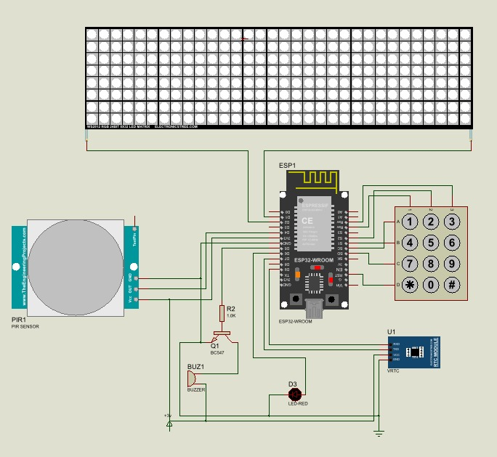
Figure 3.1 Complete Circuit Diagram of the Motion-Activated LED Schedule Display System

System Flowchart
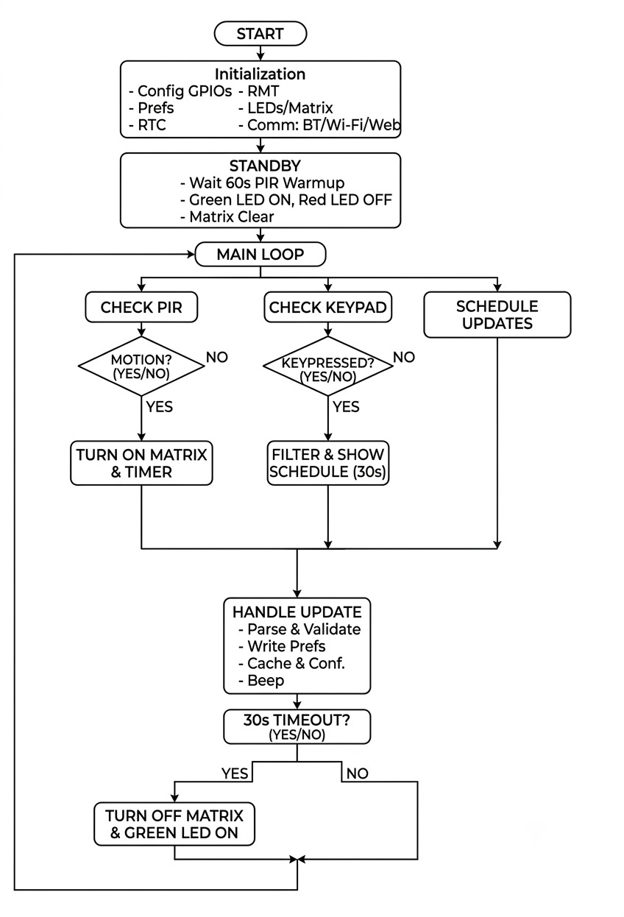
Figure 3.3 presents the complete operational flowchart of the system. On power-on, the ESP32 initialises all peripherals, loads the schedule from flash memory via the Preferences library, synchronises its internal time variable with the DS3231, and starts the Wi-Fi Access Point and Bluetooth services. It then enters the STANDBY state: the LED matrix is switched off, the green indicator LED is lit, and the processor enters light sleep with GPIO4 configured as a rising-edge wake-up source. When the PIR sensor detects human presence, a rising edge on GPIO4 wakes the ESP32 (ACTIVE state), the current time is read from the DS3231, the appropriate schedule records are retrieved, and the schedule is rendered as scrolling text on the LED matrix. A 30 s inactivity timer starts and is reset by each subsequent PIR trigger. If a keypad key (1–5) is pressed, the schedule is filtered by the corresponding academic level and displayed for 30 s before reverting to the time-based schedule. If a schedule update command arrives via Bluetooth or the web interface (UPDATE state), the new record is written to flash and a confirmation message is displayed on the matrix. When the inactivity timer expires without a new PIR trigger, the system returns to STANDBY.
Figure 3.2 System Operational Flowchart

Table 3.6 System State Truth Table
State | PIR | Display | Red LED | Green LED | Buzzer | Power Mode
Standby (no motion) | LOW | OFF | OFF | ON | OFF | Light sleep (~20 mA)
Motion detected | HIGH | ON – schedule | ON | OFF | 1 beep | Active (~250 mA)
Active (ongoing motion) | HIGH | ON | ON | OFF | OFF | Active
Timeout (30 s no motion) | LOW | OFF | OFF | ON | OFF | Light sleep
Schedule update (BT/Web) | Any | Confirmation | Flashes | Flashes | 2 beeps | Active
Keypad level press | Any | Filtered schedule | ON | OFF | 1 beep | Active

Programming
The system firmware is written in C++ using the Arduino IDE 2.x with the Espressif ESP32 Arduino core. C++ was selected for its direct hardware register access, low memory overhead, and comprehensive library support for the ESP32 peripherals employed in this design. The firmware is organised into five functional modules that are developed and tested independently before integration.

Programming Language Choice
C++ (Arduino framework) was chosen for the ESP32 firmware because it provides direct access to hardware peripherals through the ESP32 Arduino core abstraction layer while retaining the efficiency of compiled native code. MicroPython was considered as an alternative but rejected on the grounds that it does not support the RMT peripheral required for WS2812B timing and that its interpreted execution introduces jitter that can corrupt the 800 kbps LED data stream. The Arduino core additionally provides a mature ecosystem of libraries FastLED, RTClib, BluetoothSerial, AsyncWebServer, and Preferences all of which are employed in this firmware, eliminating the need for custom low-level driver development.

Summary of Circuit Design
This chapter has presented a complete electrical analysis and component-selection rationale for the motion-activated LED departmental schedule display. The ESP32 was selected for its dual-core architecture, integrated wireless peripherals, and deep-sleep capability. GPIO pin assignments were determined by hardware peripheral mapping, sleep wake-up capability, and input-only pin constraints. The WS2812B LED matrices were sized for a 5 V, 10 A supply based on calculated typical current consumption of 2.05 A. A 1 kΩ base resistor for the BC547 transistor was calculated to deliver a base current of 2.6 mA, providing a saturation margin of 9.6 times the minimum required. A standard 220 Ω series resistor limits LED indicator current to approximately 5–6 mA. The power supply design proceeds from a 12 V, 2 A transformer through a 1N4007 bridge rectifier, a 10,000 µF filter capacitor, and an LM2596 buck converter, with the LM2596 selected over the 7805 linear regulator to reduce heat dissipation from 26.4 W to 2.25 W. A 7 Ah, 12 V backup battery was sized for a minimum 4-hour runtime at 1.23 A discharge current, and a relay-based changeover circuit ensures seamless transition in less than 10 ms. The DS3231 I²C pull-up resistors of 4.7 kΩ present on the module breakout board were verified to satisfy both the minimum and maximum pull-up resistance constraints for 100 kHz I²C operation. Chapter Four will present the physical construction of the prototype, testing procedures, results, and a discussion of system performance.

REFERENCES
Hercog, D., Lerher, T., Truntič, M., & Težak, O. (2023). Design and implementation of ESP32-based IoT devices. Sensors, 23(15), 6739.
Krebs, S., & Herter, T. (2024). Ultra-wideband positioning system based on ESP32 and DWM3000 modules. arXiv preprint.
Margapuri, V. (2020). Smart motion detection system using PIR sensors. arXiv preprint.
Ogunseye, T. T., Egbeyale, G. B., Bello, A. K., & Ajani, S. A. (2021). Design and construction of a microcontroller-based electronic moving message display. arXiv preprint.
Ranasinghe, J., & Herath, D. (2023). IoT-based automatic counter for detecting student flow using PIR and ultrasonic sensors. ResearchGate publication. https://www.researchgate.net/publication/368750968
Sarkar, S., Jana, A., Maity, S., Maiti, C., & Bera, C. K. (2023). IoT-based performance display system using ESP32: Design and development. Journal of Physics: Conference Series, 2576(1), 012002.
Sulartopo, S., Wiraditama, W., Candra, D., & Nugraha, A. P. (2023). Motion detection security system based on ESP32 and PIR sensor. Jurnal Teknologi Informasi dan Komunikasi, 14(2), 395–401. https://doi.org/10.51903/jtikp.v14i2.779
Vales, V. B., Bolaño, T. D., Fernández, O. C., García-Naya, J. A., & Escudero, C. J. (2024). Fine time measurement for the Internet of Things using ESP32. arXiv preprint.
Zaghlool Mahmood, R. (2022). High accurate automatic school bell controller based on ESP32 Wi-Fi. Technium Romanian Journal of Applied Sciences and Technology, 4(10), 126–144. https://doi.org/10.47577/technium.v4i10.7929

